Smart Farmer-IOT Enabled Smart Farming Application

**CREATE NODE RED**

|  |  |
| --- | --- |
| TITLE | Smart Farmer-IOT Enabled Smart Farming  Application |
| DOMAIN NAME | INTERNET OF THINGS |
| TEAM ID | PNT2022TMID42723 |
| LEADER NAME | NISHANTH G |
| TEAM  MEMBERS  NAME | KESAVAMOORTHI J  MAYAVAN A  SARAVANAPERUMAL V |

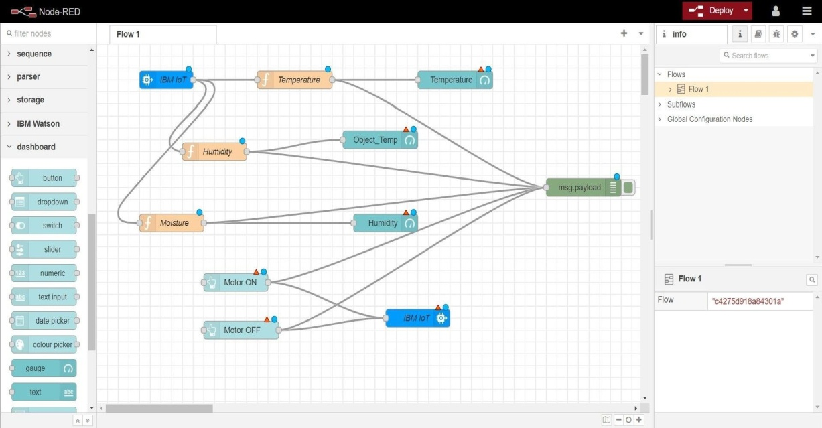STEP 1:-

STEP 2:-